Scoil Raifteirí, 23.10.13.
A Thuistí,
Mar is eol daoibh, táimid ag obair i dtreo an Séú Bhratach Glas a fháil. Is é an téama ná Saoránacht Domhanda, le béim ar bhruscar. As you probably know, we’re working on the theme Global Citizenship: Litter and Waste to get our sixth Green Flag. The students are learning about global issues, and their projects are featured on our website. http://www.scoilraifteiri.com/greenflag20122013.htm
An tseachtain seo, tá trí rud ar siúl. This letter is to inform you of three projects launched this week.
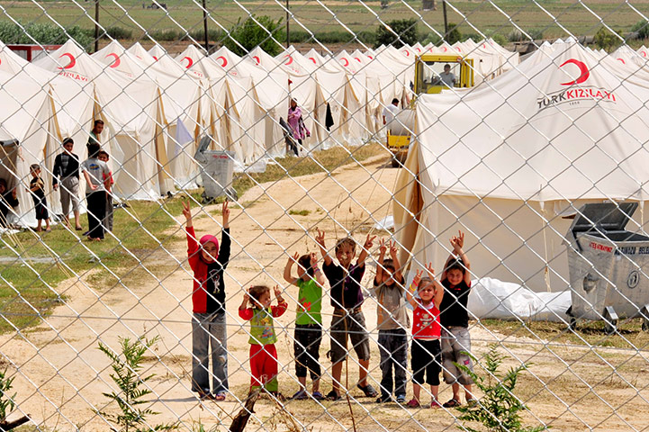

Action for Syria. Táimid ag bailiú €1 ó pháistí atá ag iarraidh gléasadh suas ar an Aoine: the school will be alive with vivid costumes on Friday instead of the usual uniform! All children are aware of the hardships of young Syrian refugees, and this money will be of help to them.
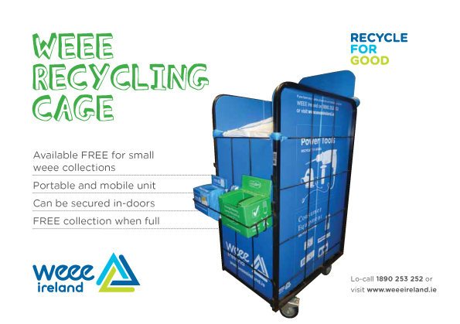

Tá tralaí mór faighte ag an scoil chun sean trealamh leictreach a bhailiú. Scoil Raifteirí will be operating as a WEEE collection station. We will accept your discarded electrical devices, like monitors or keyboards, and all sorts of light bulbs, and keep them at the school for collection by WEEE for transport to their recycling centre in Cork.
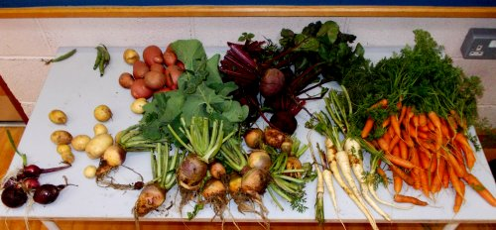

Féach ar na glasraí áille a fuaireamar ar an Luan! The last of our vegetable harvest took place on Monday. Instead of making soup this time, we’ll be presenting the veggies to the children of one lucky class to take home.
Ní neart go cur le chéile!

